**Chiến lược quản lý các bên liên quan**

Bạn có thể sao chép và sử dụng miễn phí Mẫu chiến lược quản lý các bên liên quan trong dự án này cho dự án và trong tổ chức của mình. Chúng tôi hy vọng rằng bạn thấy mẫu này hữu ích và hoan nghênh ý kiến ​​của bạn. Việc phân phối công khai tài liệu này chỉ được phép từ trang web chính thức của Tài liệu quản lý dự án tại:

[ProjectManagementDocs.com](http://www.projectmanagementdocs.com/)

**Chiến lược quản lý các bên liên quan**

**<Tên dự án>**

**Tên công ty**

**Địa chỉ đường phố**

**Thành Phố, Tiểu Bang Mã Bưu Chính**

**Ngày**

**Mục lục**

1. Giới thiệu 3

2. Xác định các bên liên quan 3

3. Các bên liên quan chủ chốt

4. Phân tích các bên liên quan 5

# Giới thiệu

Phần này nên giới thiệu và thảo luận về các mục đích và mục tiêu của Chiến lược quản lý các bên liên quan cho dự án. Quản lý hiệu quả các bên liên quan là một thành phần quan trọng của quản lý dự án thành công và không bao giờ được bỏ qua. Quản lý các bên liên quan thích hợp có thể được sử dụng để đạt được sự hỗ trợ cho một dự án và dự đoán các mục tiêu kháng cự, xung đột hoặc cạnh tranh giữa các bên liên quan của dự án.

Chiến lược quản lý các bên liên quan cho Dự án Cáp LightWave của FiberTech sẽ được sử dụng để xác định và phân loại các bên liên quan của dự án; xác định quyền lực, lợi ích và ảnh hưởng của các bên liên quan; và phân tích phương pháp quản lý và phương pháp truyền thông cho các bên liên quan của dự án. Điều này sẽ cho phép chúng tôi xác định các bên liên quan có ảnh hưởng chính để thu hút đầu vào cho việc lập kế hoạch dự án và nhận được sự hỗ trợ khi dự án tiến triển. Điều này sẽ mang lại lợi ích cho dự án bằng cách giảm thiểu khả năng gặp phải các mục tiêu cạnh tranh và tối đa hóa các nguồn lực cần thiết để hoàn thành dự án.

Việc xác định và liên lạc sớm với các bên liên quan là bắt buộc để đảm bảo sự thành công của Dự án LightWave bằng cách nhận được hỗ trợ và đầu vào cho dự án. Một số bên liên quan có thể có những lợi ích có thể bị ảnh hưởng tích cực hoặc tiêu cực bởi Dự án LightWave. Bằng cách bắt đầu trao đổi sớm và thường xuyên và quản lý các bên liên quan, chúng ta có thể quản lý và cân bằng hiệu quả hơn những lợi ích này trong khi hoàn thành tất cả các nhiệm vụ của dự án.

# Identify Stakeholders

This section should discuss the methodology the project team will use to identify stakeholders and how stakeholders are defined. It is imperative that all stakeholders are identified regardless of how major or minor they are. This is because they will be categorized after they’re identified. If stakeholders are omitted there is a likelihood that they may become evident at some point during the project’s lifecycle and introduce delays or other obstacles to the project’s success. Great care and effort should be dedicated to this step of the Stakeholder Management Strategy.

The LightWave Project Team will conduct a brainstorming session in order to identify stakeholders for the project. The brainstorming session will include the primary project team and project sponsor. The session will be broken down into two parts. The first part will focus on internal stakeholders within FiberTech. These stakeholders may include functional managers, operations personnel, finance personnel, warehouse and material handlers, and any other FiberTech employee who will be affected by the LightWave project. The second part of the session will focus on external stakeholders. These may include suppliers, trial customers, partner organizations, or any other individuals who reside outside of FiberTech.

The following criteria will be used to determine if an individual will be included as a stakeholder:

1. Will the person or their organization be directly or indirectly affected by this project?
2. Does the person or their organization hold a position from which they can influence the project?
3. Does the person have an impact on the project’s resources (material, personnel, funding)?
4. Does the person or their organization have any special skills or capabilities the project will require?
5. Does the person potentially benefit from the project or are they in a position to resist this change?

Any individual who meets one or more of the above criteria will be identified as a stakeholder. Stakeholders from the same organization will be grouped in order to simplify communication and stakeholder management.

# Key Stakeholders

This identifies the sub-set of stakeholders who have been identified as key stakeholders and the reasoning for determining that they are key stakeholders. Key stakeholders are often those who potentially have the most influence over a project or those who may be most affected by the project. They may also be stakeholders who are resistant to the change represented by the project. These key stakeholders may require more communication and management throughout the project’s lifecycle and it is important to identify them to seek their feedback on their desired level of participation and communication.

As a follow on to Identify Stakeholders, the project team will identify key stakeholders who have the most influence on the project or who may be impacted the most by it. These key stakeholders are those who also require the most communication and management which will be determined as stakeholders are analyzed. Once identified, the Project Manager will develop a plan to obtain their feedback on the level of participation they desire, frequency and type of communication, and any concerns or conflicting interests they have.

Based on the feedback gathered by the project manager, the determination may be made to involve key stakeholders on steering committees, focus groups, gate reviews, or other project meetings or milestones. Thorough communication with key stakeholders is necessary to ensure all concerns are identified and addressed and that resources for the project remain available.

# Stakeholder Analysis

This section describes how the project team will analyze its list of identified stakeholders. This discussion should include how stakeholders will be categorized or grouped as well as the level of impact they may have based on their power, influence, and involvement in the project. There are several tools and techniques that can be used to help quantify stakeholders. A description of these tools and techniques should also be included in this section.

Once all LightWave Project stakeholders have been identified, the project team will categorize and analyze each stakeholder. The purpose of this analysis is to determine the stakeholders’ level of power or influence, plan the management approach for each stakeholder, and to determine the appropriate levels of communication and participation each stakeholder will have on the project.

The project team will categorize stakeholders based on their organization or department. Once all stakeholders have been categorized, the project team will utilize a power/interest matrix to illustrate the potential impact each stakeholder may have on the project. Based on this analysis the project team will also complete a stakeholder analysis matrix which illustrates the concerns, level of involvement, and management strategy for each stakeholder.

The chart below will be used to establish stakeholders and their levels of power and interest for use on the power/interest chart as part of the stakeholder analysis.

| Key | Organization | Name | Power (1-5) | Interest (1-5) |
| --- | --- | --- | --- | --- |
| A | Operations | A. White | 2 | 2 |
| B | Operations | B. Brown | 4 | 5 |
| C | Supplier | C. Black | 1 | 1 |
| D | Supplier | D. Green | 1 | 2 |
| E | Trial Customer | E. Day | 3 | 5 |
| F | Engineering | F. Knight | 4 | 1 |
| G | Engineering | G. Smith | 2 | 4 |
|  |  |  |  |  |

Below is the power/interest chart for the LightWave Project stakeholders. Each letter represents a stakeholder in accordance with the key in the chart above.

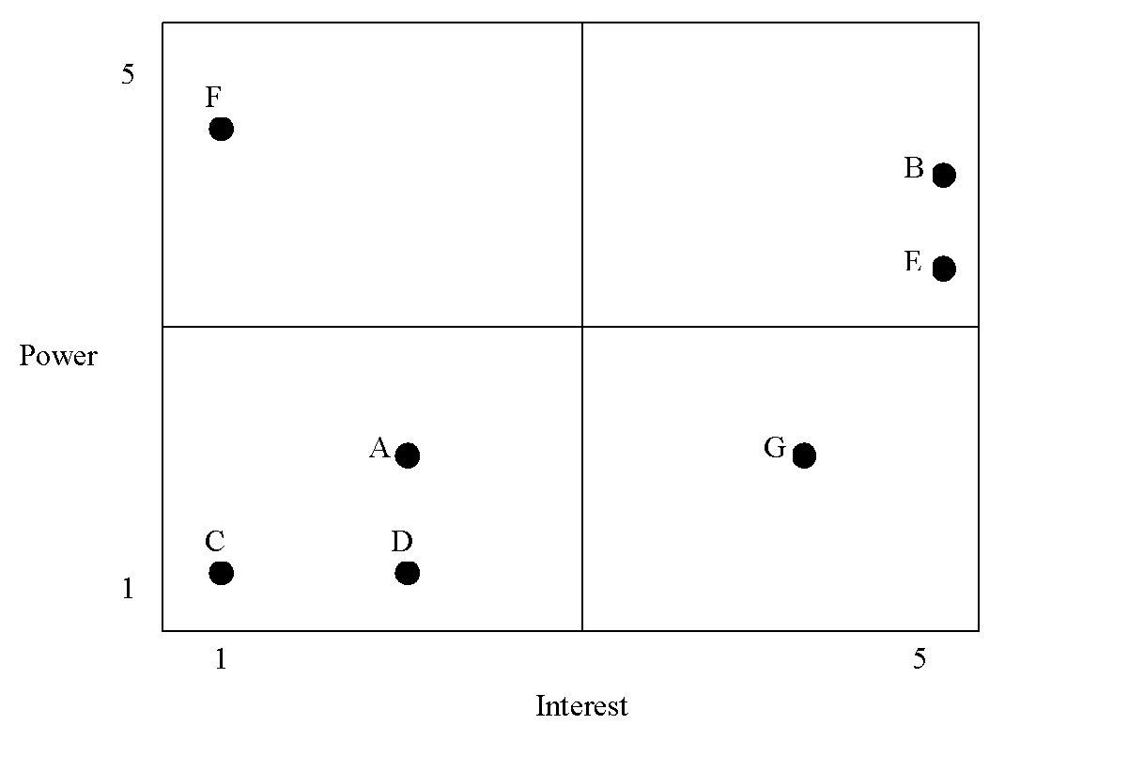

Based on the power and interest analysis and chart above, stakeholders A, C, and D will require minimal management effort as they reside in the lower left quadrant of the matrix. Stakeholder F, in the upper left quadrant, must be kept satisfied by ensuring concerns and questions are addressed adequately. Stakeholder G, in the lower right quadrant, must be kept informed through frequent communication on project status and progress. Stakeholders B and E, in the upper right quadrant, are key players and must be involved in all levels of project planning and change management. Additionally, stakeholders B and E should be participatory members in all project status meetings, gate reviews, and ad hoc meetings as required.

The stakeholder analysis matrix will be used to capture stakeholder concerns, level of involvement, and management strategy based on the stakeholder analysis and power/interest matrix above. The stakeholder analysis matrix will be reviewed and updated throughout the project’s duration in order to capture any new concerns or stakeholder management strategy efforts.

| Stakeholder | Concerns | Quadrant | Strategy |
| --- | --- | --- | --- |
| A | Ensuring proper handover of project to operations team | Minimal Effort | Communicate project specifications as required |
| B | Resource and scheduling constraints for production once project is transitioned to operations | Key Player | Solicit stakeholder as member of steering committee and obtain feedback on project planning. Frequent communication and addressing concerns are imperative |
| C | Ensuring on time delivery of materials | Minimal Effort | Communicate project schedule and material requirements ahead of time to ensure delivery |
| D | Possible union strike may impact material delivery | Minimal Effort | Solicit frequent updates and develop plan for alternative supply source |
| E | Product performance must meet or exceed current product | Key Player | Communicate test results and performance specifications and obtain feedback on customer requirements or any changes. Provide frequent status reports and updates. |
| F | Concerns regarding resources to assist project team with product design | Keep Satisfied | Communicate resource requirements early and ensure resources are released back to engineering when they’re no longer required |
| G | Questions regarding design of LightWave product | Keep Informed | Allow technical staff to work with stakeholder to answer questions and address concerns and provide test results for validation |

**Sponsor Acceptance**

Approved by the Project Sponsor:

Date:

<Project Sponsor>

<Project Sponsor Title>

This free Stakeholder Management Strategy Template is brought to you by [www.ProjectManagementDocs.com](http://www.projectmanagementdocs.com)